/******************************************************************************
***
* DPS912-Assignment-1
* I declare that this lab is my own work in accordance with Seneca Academic Policy.
* No part of this assignment has been copied manually or electronically from any other source
* (including web sites) or distributed to other students.
*
* Name: Mansoor Ahmad Zafar
* Student ID: 100503226
* Date: Friday, 26th, 2026
******************************************************************************
**/
D1) On a scale from 1 to 5, How much did you use generative AI to complete this
assignment?
▪ where:
▪ 1 means you did not use generative AI at all
▪ 2 means you used it very minimally
▪ 3 means you used it moderately
▪ 4 means you used it significantly
▪ 5 means you relied on it almost entirely
▪ Your answer : 2
o D2) On a scale from 1 to 5, How confident are you in your understanding of the
generative AI support you utilized in this assignment, and in your ability to explain it if
questioned?
▪ where:
▪ 1 means "Not confident at all – I do not understand the generative AI support I used
and cannot explain it."
▪ 2 means "Slightly confident – I understand a little, but I have many uncertainties."
▪ 3 means "Moderately confident – I understand the majority of the support, though
some parts are unclear."
▪ 4 means "Very confident – I understand most of the AI support well and can explain
it with minor gaps."
▪ 5 means "Extremely confident – I fully understand the generative AI support I used
and can clearly explain or justify it if asked."
▪ Your answer: 5

Part 1:
1.
We use O_CREAT to create the file if it doesn't exist, since for the first time opening/creating it, it won't exist, so we want to ensure it exists by creating it if it doesn't. We use O_TRUNC to remove all the content to previously in the file and not append to it

2.
if write() fails, it returns -1 and doesn't write anything inside the file. It does NOT crash or exit the program.

3.
We use memset since we need to initialize some data, if we try reading uninitialized data in buffer by not doing memset, we're reading garbage values that can be anything, this is undefined behavior as there is no guarantee to what will happen

Part 2:
1.
We check /proc/self/status for usage as /proc/self will tell us details about our running process and /status tells us the runtime details of our process. So to see runtime values of our process and see the memory in runtime and real-time, we use /proc/self/status

2.
nothing happens to the parent, but kill() returns -1 and sets an error code in errno, but doesn't crash and the receiving process is not told anything.

3.
In blocking mode, we wait for data if there is none yet whereas for non-blocking, we immediately return -1 and move on. Blocking waits for EOF and won't set errno but non-blocking will set errno and return an error.

Part 3:
1.
Only 1 signal then gets to be processed. Signals aren't queued, the signals are marked as pending but since they aren't queued, only 1 is processed and the other is dropped and lost

2.
The signal(SIGUSR1, xx_signal_handler) is needed in main, because we need to handle the signal call from the child to the parent. The signal function lets us define a custom handler to handle the SIGUSR1 with our custom signal handler function and allows us to handle the notification from the child to the parent.

Part 4:
1.
F_WRLCK is a lock to a file descriptor and acts as a mutex, where it ensures only 1 process can write to a file at a time having locks and unlock mechanisms. Being able to lock the file so nothing else can access and being able to unlock it so the other resources can access the file. We use it when we want to guarantee 1 resource at a time can access a file, so usually threaded solutions.

2.
It prevents data corruption as only 1 resource can access the file at a time, preventing multiple files writing to the file at the same time. Ensuring they go after each other, ensuring no data is overwritten as nobody can go until the person with the lock is done.

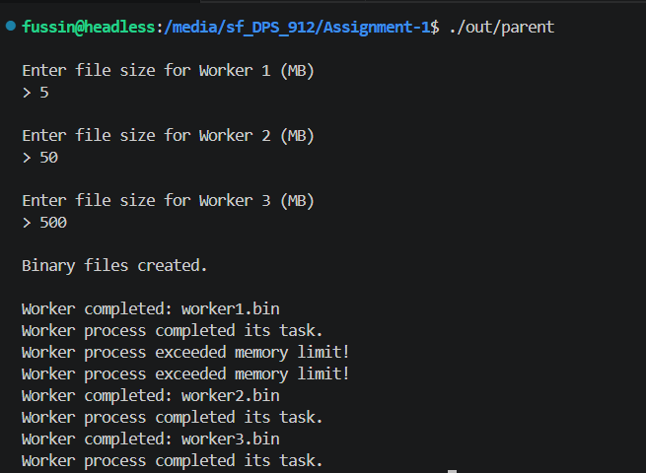

Video:
https://youtu.be/koqL3cMgdNU

